Multiple Intelligences

- MI Quiz to determine area of intelligence
- Create MI illustration
  - Picture of self
  - Labels Top 3 Areas of Intelligence
  - 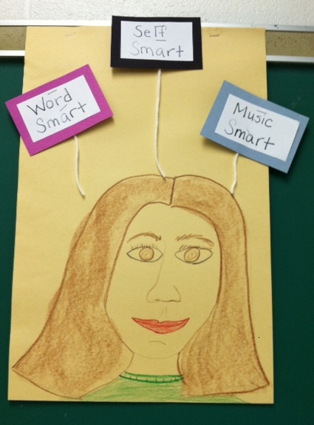
- MI Presentation on ME
  - Choose top area of intelligence
  - Create presentation on self based on that area of intelligence
    - i.e.- a musically intelligent person might write and perform a song on self
    - i.e- a number logic person might create a puzzle/problem about self for class to figure out.
    - Creative
Multiple Intelligences Presentation

- Choose one of your top three intelligences.
  - _________________ Smart
- Choose one area of your life that you would like to tell the class about. Your job is to create a presentation using the type of intelligence you chose.
  - For example, a person who is Music Smart might write a song about their life and perform it for the class. A number or logic smart person might create a puzzle for the class to solve about their life.
  - What will your presentation be? Write a short description. ________________________________________________________________________________________________________________________________________________________________________
    - Mrs. Walters’ Initials __________________
    - Parent’s Initials _________________
- You will have two weeks to prepare your presentation. These will be performed in AR class on ____________________________. You may present early if you are prepared to do so.
- Have fun!!!

